EXPERIMENT 6
AIM: 1. Write ns3 simulation program to show use of topology helpers for creating a network.
NS-3 CODE: (Dumbell topology)

#include <iostream>

#include "ns3/core-module.h"
#include "ns3/network-module.h"
#include "ns3/internet-module.h"
#include "ns3/point-to-point-module.h"
#include "ns3/netanim-module.h"
#include "ns3/applications-module.h"
#include "ns3/point-to-point-layout-module.h"

using namespace ns3;

int main(int argc, char* argv[])
{
Config::SetDefault("ns3::OnOffApplication::PacketSize", UintegerValue(512));
Config::SetDefault("ns3::OnOffApplication::DataRate", StringValue("500kb/s"));

uint32_t nLeftLeaf = 5;
uint32_t nRightLeaf = 5;
uint32_t nLeaf = 0; // If non-zero, number of both left and right
std::string animFile = "dumbbell-animation.xml"; // Name of file for animation output

CommandLine cmd;
cmd.AddValue("nLeftLeaf", "Number of left side leaf nodes", nLeftLeaf);
cmd.AddValue("nRightLeaf", "Number of right side leaf nodes", nRightLeaf);
cmd.AddValue("nLeaf", "Number of left and right side leaf nodes", nLeaf);
cmd.AddValue("animFile", "File Name for Animation Output", animFile);

cmd.Parse(argc, argv);
if (nLeaf > 0) {
nLeftLeaf = nLeaf;
nRightLeaf = nLeaf;
}

// Create the point-to-point link helpers
PointToPointHelper pointToPointRouter;
pointToPointRouter.SetDeviceAttribute("DataRate", StringValue("10Mbps"));
pointToPointRouter.SetChannelAttribute("Delay", StringValue("1ms"));
PointToPointHelper pointToPointLeaf;
pointToPointLeaf.SetDeviceAttribute("DataRate", StringValue("10Mbps"));
pointToPointLeaf.SetChannelAttribute("Delay", StringValue("1ms"));

PointToPointDumbbellHelper d(nLeftLeaf, pointToPointLeaf,
nRightLeaf, pointToPointLeaf,
pointToPointRouter);

// Install Stack
InternetStackHelper stack;
d.InstallStack(stack);

// Assign IP Addresses
d.AssignIpv4Addresses(Ipv4AddressHelper("10.1.1.0", "255.255.255.0"),
Ipv4AddressHelper("10.2.1.0", "255.255.255.0"),
Ipv4AddressHelper("10.3.1.0", "255.255.255.0"));

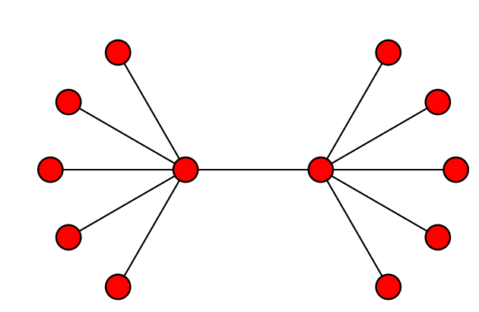

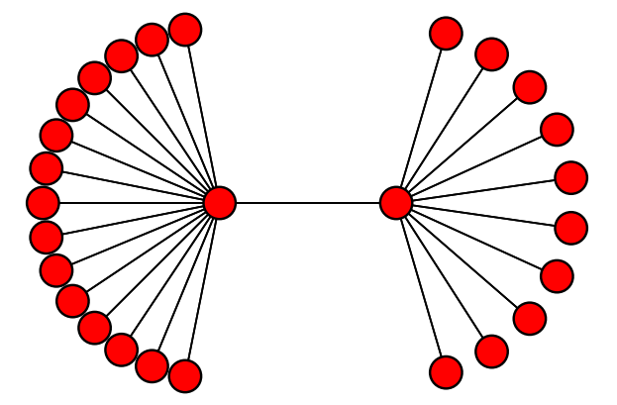

// Install on/off app on all right side nodes
OnOffHelper clientHelper("ns3::UdpSocketFactory", Address());
clientHelper.SetAttribute("OnTime", StringValue("ns3::UniformRandomVariable"));
clientHelper.SetAttribute("OffTime", StringValue("ns3::UniformRandomVariable"));
ApplicationContainer clientApps;

for (uint32_t i = 0; i < ((d.RightCount() < d.LeftCount()) ? d.RightCount() : d.LeftCount()); ++i) {
// Create an on/off app sending packets to the same leaf right side
AddressValue remoteAddress(InetSocketAddress(d.GetLeftIpv4Address(i), 1000));
clientHelper.SetAttribute("Remote", remoteAddress);
clientApps.Add(clientHelper.Install(d.GetRight(i)));
}

clientApps.Start(Seconds(0.0));
clientApps.Stop(Seconds(10.0));

// Set the bounding box for animation
d.BoundingBox(1, 1, 100, 100);

// Create the animation object and configure for specified output
AnimationInterface anim(animFile);
anim.EnablePacketMetadata(); // Optional
anim.EnableIpv4L3ProtocolCounters(Seconds(0), Seconds(10)); // Optional

// Set up the actual simulation
Ipv4GlobalRoutingHelper::PopulateRoutingTables();

Simulator::Run();
std::cout << "Animation Trace file created:" << animFile.c_str() << std::endl;
Simulator::Destroy();
return 0;
}

COMMANDS

>>./waf --run scratch/dumbbell-animation --vis
>>./waf --run "scratch/dumbbell-animation --nLeaf=10" --vis
>>./waf --run "scratch/dumbbell-animation --nLeftLeaf=10 --nRightLeaf=4" --vis

